***Team 01-07***

***Team Members:***

***Jm Tameta, Matt Sacco, Matt Shea, Meghan McConnell, Sarah Phung,***

***Val Roberts***

***ACC 311/CSC 315***

***Energy Demand***

***(IIb) Final Project Proposal & Specifications***

*Feedback from IIa Submission*

*“Include a discussion about security and backup/recovery after your project departs GitHub and is delivered to TCNJ Facilities.”*

***Problem***

Currently The College of New Jersey does not have a centralized database that provides information regarding the energy consumption of all buildings on campus. In addition there does not exist a user-friendly web application associated with said database; therefore one must search through multiple excel sheets to find and analyze the data they need. Furthermore due to the lack of a database, visualization tools such as graphs and infographics are not readily available.

***Proposed Solution***

In order to address the problem stated above our team will design, develop, and implement a centralized database that will focus on the two different energy sources used throughout campus: natural gas and electricity. Our initial approach will be evaluating our current datasets, focusing on the different energy usage and associated cost for each building on campus, and calculating the cost for future buildings. We can not state yet if we’re going to focus on residential halls or academic buildings because we have not determined the relationship between the buildings and the list of electric and natural gas meters.

However, our backup plan if we are unable to obtain the relationship between the meters and the on campus buildings, we will instead approach the entire campus’s energy consumption by focusing more on the square footage of buildings. We are currently evaluating if we can create the relationship between a building’s square footage and the energy it can potentially consume.

***Existing Solution***

At the moment a centralized building energy demands database does not exist, therefore we are referencing other resources such as the TCNJ Covid and Kibana user interface dashboards. We are also considering ecommerce websites where users are able filter their view of the company’s products.

***Research & Data Collection***

We plan to build a centralized database that makes all the data regarding the demand of energy at the college easy to read. Different filters will be added so that data relating to specific buildings can be displayed. For example, if one wishes to look at energy demand in relation to residence halls or science buildings on campus, a filter can be applied. Data was given to us about the costs of each meter at TCNJ, dating back to 2009. There are different types of energy used at the college, including natural gas and electric. These excel files provide insightful information such as the electric and natural gas energy usage and their respective costs. Costs relating to natural gas come from the college, but costs relating to the electric after provided by PSE&G. We will need to into this company to see where these costs come from. Data specifically describing which meter relates to certain buildings is not available to us. This became clear after speaking with Mr. Romano. We will have to allocate the costs to each building based on its usage or square footage.

We will begin by looking at residential buildings. These buildings house many students and demand a lot of energy to power. We are aware of the college’s Greener Going Forward Sustainability Plan therefore we are hoping to provide a total amount of carbon equivalent emissions from each residential building. After this, we will begin to look at educational buildings on campus.

From the data provided to us from Mr. Romano, we will be focusing on a few key tabs of data. The properties data has been sorted and cleaned up to make it easier to read. In the “Properties” tab, we will utilize the gross floor area and occupancy in determining the distribution of energy demand. Data from the “Meter Entries” tab to analyze the cost of the meters at TCNJ by month, dating back to July 2009. This tab provides the usage and quantity, usage units and costs associated with each meter. The meter type, natural gas or electric, is also specified.

***Software Specific - Need to Edit & Address Feedback***

Possible other applications of the system (how it could be modified and reused.)

* + The application can be reused for other recurring costs for each of the buildings, such as water and other resource usage.
  + Resource consumption by building as a calculator can be refitted to be any resource by any other additional unit as a way to gauge what changes to external, overarching units need to be done in order to maximize efficiency.
* Performance – specify how and to what extent you will address this.
  + We will utilize a database containing administrator-placed data that interfaces with a web page.
  + Graphics and graphs will be generated dynamically using user-created filters.
* Security - specify how and to what extent you will provide security features
  + User authentication, two different types of profiles in order to help compartmentalize different user access abilities.
    - An administrator account that is able to update the database with new information.
    - A basic user account that is only able to view the profile.
* Backup and recovery – specify how and to what extent you will implement this
  + Recovery of previous versions of the tool can be done through version control via GitHub.
* Technologies and database concepts the team will need to learn, and a plan for learning these
  + The MVR model and displaying information.
  + Setting up a stack for a web based application utilizing said database.
  + Population of database with cleaned data.
* Handover Process
  + Administrator credentials/setup instructions will be handed over to college once initial development lifetime is completed.
  + Instructions for management will be added as documentation for future users.

***Diagrams - And UI Mockup***

1. A diagrammatic representation of the system boundary that specifies what data you will model and which queries you will implement 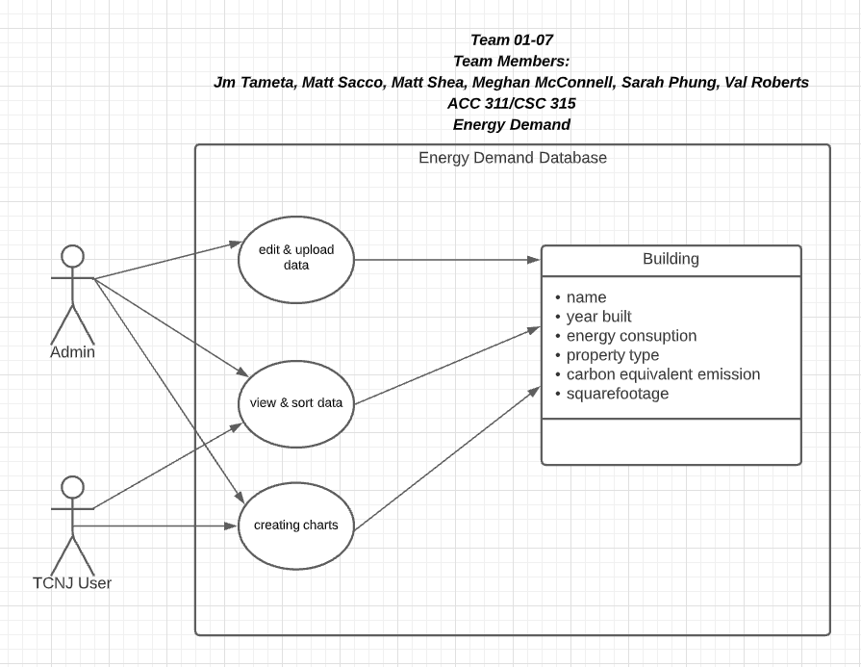
2. 1-page quad chart 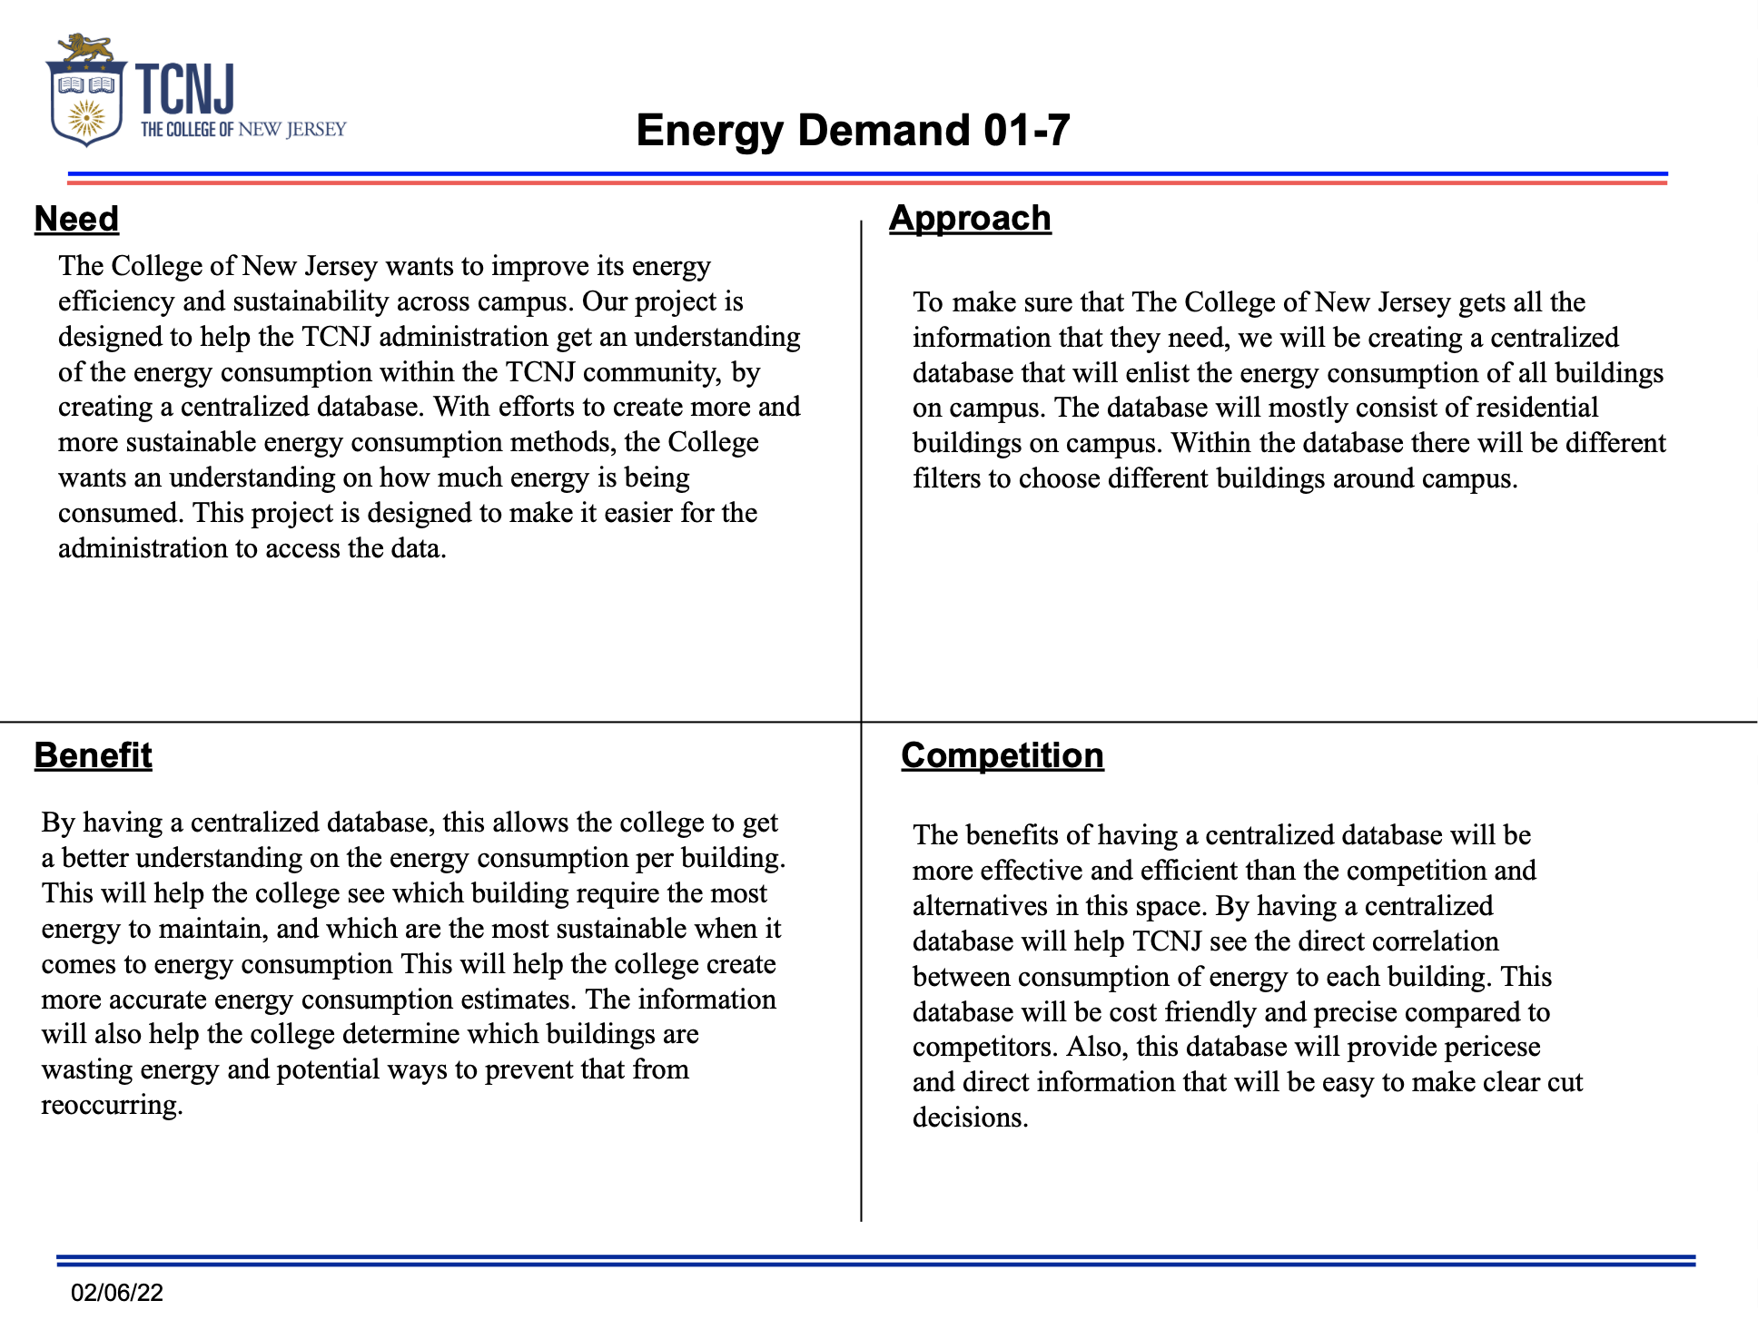
3. UI mockup